Name_______________ Due Date__________
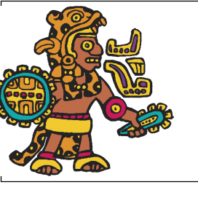
Theme Park Project: Maya, Aztec and Inca.

Create an amusement park map and legend (key) that includes the important themes of the Maya, Aztec and Inca!

1. Make a list of key terms of each society you want to represent.
2. Must include: A section for Maya, Aztec & Inca, including rides, shops, shows & games.
3. The fourth section can be a mix of all three civilizations and can be focused on restaurants, gifts and restrooms.
3. Include information regarding. Achievements, Government, Religion, Life Style and Decline.
4. Draw and color your map making sure that your roads are clear and that you have clear names and description for each attraction.
5. Be creative: ☺ Ex. Head Hunters height chart to measure yourself before you get on the death defying ride.

THIS PROJECT IS WORTH 50 POINTS!

Students’ reflection: 1 least 3 highest. Circle one.
Effectiveness of Project: 1 2 3
Prefer an exam: 1 2 3
________________________________________________________________________________________
√ | Requirements | Score 1-10
 | Theme Park has at least 15 rides & attractions
 | Key terms & vocabulary are used
 | Information corresponds to the correct civilization & time period
 | Effort
 | Creativity & Color
 | Total

Comment: _____________________________________________________________________________
Final Grade: _____________

Maya  Theme Park Name &  Mission Statement | Aztec
Inca | ALL 3 Civilizations:  Gifts, games,  Restaurants & Restrooms


