Feudalism comes to Europe
The Middle Ages lasted from about 500 to 1450. During this time Europe was cut off from the world. Population decreased and towns emptied. Trade almost ended. Learning stopped. Invaders such as Vikings and Germanic tribes destroyed communities in Europe. The people live in great fear and they are hungry and tired. They find a leader, and they promise him that if he will protect them, they will serve him the rest of their lives. They become suspicious of outsiders, fearing strangers are trying to find a way to attack them. A few merchants may come with goods to sell, but how will they pay for these goods? Since they could not get to outside goods, and goods could not get to them, they would have to learn to produce everything on their own.
A new system called feudalism, developed. In feudal society, powerful lords owned large pieces of land. They divided their land into estates called fiefs. Fiefs were given to less powerful lords, called vassals. The vassal promised loyalty and military service to his lord. The lord promised to protect the vassal. The nobles were vassals of the king; the peasant was vassal to the nobleman. The king had authority over the nobles, but could not give orders to the peasant, who was the noble’s servant.
The medieval economy was based on the manor, or lord’s estate. Peasants lived and worked on the manor. Most people were peasants or serfs. Serfs were not slaves, but they had to stay and work on the land. They farmed for the lord and repaired roads. The lord charged them fees for grinding wheat, inheriting land or marrying. In exchange, they received a small amount of land to farm and protection from Barbarian raids or feudal warfare.
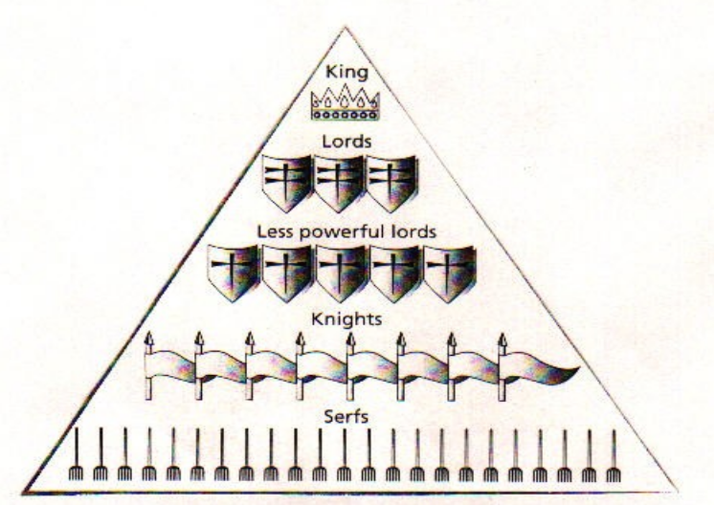

True or False
- ____The people were scared of attacks from outsiders.
- ____Merchants brought them all the goods they needed.
- ____Only the king could give orders to the peasants.
- ____In return for land and protection the lord received military service.
- ____Most of society was made up of nobleman (lords).
- Why did feudalism develop?

- Provide a positive and a negative of this system?

Name______________________________
Middle Ages: Feudalism/Manor/Castles

The Fall of Rome-_______________ invade/Roman Empire ________
____________ Europe:  Byzantine Empire  Preserves __________ & __________. | _____________ Europe:  500-1500 AD  Middle/Medieval/Dark Ages. Culture and learning limited.
I. The Age of Charlemagne
A. Charlemagne: 742-814. Charles the Great
1. Over ________ feet tall and strapping.
2. ____________________ much of the old Roman Empire including; ___________, ____________________, and parts of ______________.
3. Fought the ___________________, ________________ and _______________.
4. Charlemagne spread ________________ through __________________.
5. Charlie had become the most powerful king in ___________________________!!!
6. The ________________ of Charlemagne joined _____________________ power, the _______________, and the heritage of the _____________________________.
7. Encouraged __________________.
8. Surrounded himself with many ___________________.
9. Opened _____________________ for his children and children of the court.
10. Empire ____________________ after his death.
11. ________________________: divided the empire into 3 separate kingdoms: 843

II. Feudalism: Government
A. System of __________________ based on __________________.
Need for __________________
2. Kings _________________ too rule
3. Local lords governed own _______, but owed ___________ service to a _______________ lord.
4. System determined by __________.
5. ____________________

B. Key Terms
1. Lord= _________________
2. _________=Person receiving the land
3. Fief= ________
4. Serfs/ __________=worked the land

C. The Feudal Pyramid
1. Nobles (Lords) gave the Vassal ______ in exchange for ____________
______________________ as well as other services.
a. Could have ________ than one __________.
b. ___________: owed his 1st loyalty
c. Many __________ trained from a young age to become a knight.
2. _____________
a. Job is to _____________. Constant warfare
b. _________________: code of conduct
c. Need to be ___________________________________.
3. Women
a. Women to be _______________ and ________________.
b. ______________: Poets told stories of ______________.
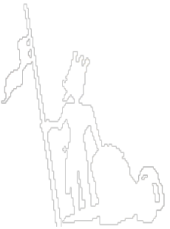
4. Serfs/Peasants
a. Worked day & night
b. ________________________-94% of population
c. ___________________ & lord
d. Paid with food________________
5. Children
a. Many died
b. Hard life
c. ___________________________

III. The Manor-Economics
A. Lord’s estate
1. Focus: ____________ & ___________________
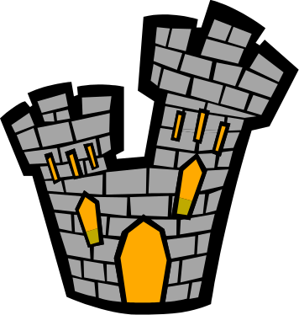
2. _____________________: everything needed for survival
3. Little ________________________
a. Kept _____________ in the _______.

IV. Castles
A. Made for _______________
1. Surrounded by __________
2. ________________ & 3. __________ windows
Name________________________
Unit: Middle Ages

The Manor: It was the heart of the medieval economy. It was the Lord’s Estate. The lord allowed people to live on his manor in return for labor, loyalty and money. Most were serfs who were bound to the land. They could not leave the manor without the lord’s permission. There were mutual rights and responsibilities. Peasants produced almost everything they needed food, clothing, tools and furniture. Most peasants never ventured more than a few miles from their village.

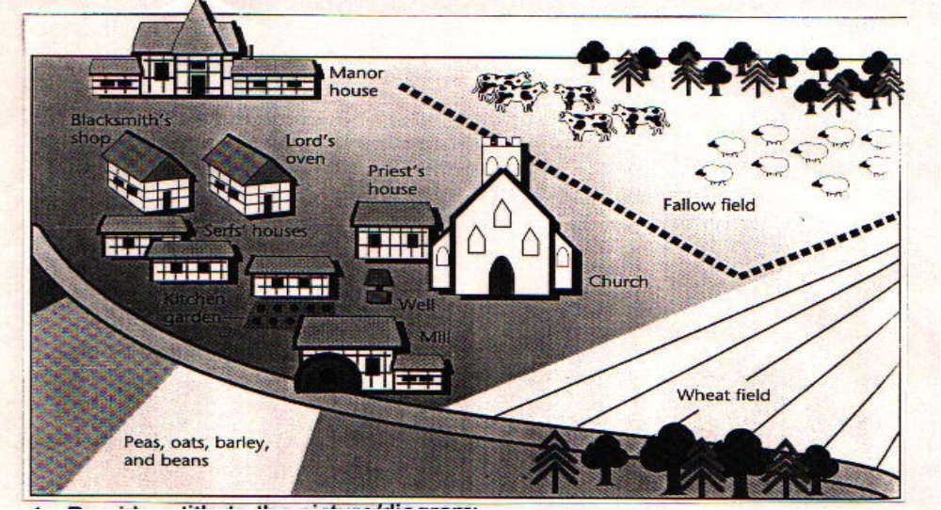

- List three types of buildings and the purpose for each.
a.
b.
c.

- What type of livestock was raised? What type of food was grown?

- How do you know that religion played an important role in manor life?

- What evidence in the diagram supports the statement that each manor was a small self-sufficient world?

- How would this effect life in Europe?

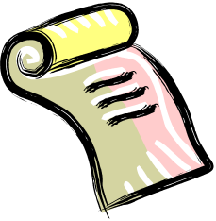
A Feudal Contract
The following selection is adapted from a feudal contract made in the year 1110.

Lord Atton: I, Bernard Atton of Carcassone, acknowledge to my lord Leo of St. Mary, that I hold as a fief in Carcassone the following castle and manors…For all of these fiefs, I swear that I will always be a faithful vassal to thee and I will defend thee, against all invaders. Moreover I acknowledge that I and my successors ought to come to St. Mary as often as I should. And when the abbot (Lord Leo) shall mount his horse, I and my heirs ought to hold the stirrup. The first time the new abbot enters Carcassone I will supply him with the best fish and meat and with eggs and cheese and pay for the expense of shoeing his horse. And if I or my sons or their successors do not observe to thee or thy successors each and all the things declared above, we wish to be handed over to thee and thy successors.

Lord Leo: I, therefore, concede to thee all the castles and manors as a fief. And I promise to thee and thy heirs that I will be a good and faithful lord concerning all those things described above.

True or False:
_____1. Lord Atton gains a fief as a result of this contract.
_____2. Lord Leo owes obligation to Lord Atton.
_____3. Lord Atton has to defend the fief and give food to Lord Leo when he visits.
_____4. Lord Leo can take away the fief at any time.
_____5. Lord Leo promises to be a good and faithful lord.

6. How do you know that this contract is intended to remain in effect after Lord Atton and Lord Leo die?

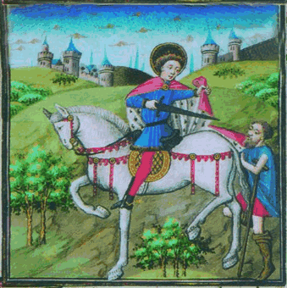
7. Who do you think has the better end of the bargain?

