Name_________________________
Fall of the Roman Empire Power Point Notes

Fall of Rome 284-476 AD
A. ___________________________
1. 50 years-26 emperors-25 killed
B. Reformers
1. Diocletian: 284 A.D. ______________________________
2. Constantine 312 Ad-East Capital-Constantinople
a. Edict of Milan. ______________________________.
__________________________________
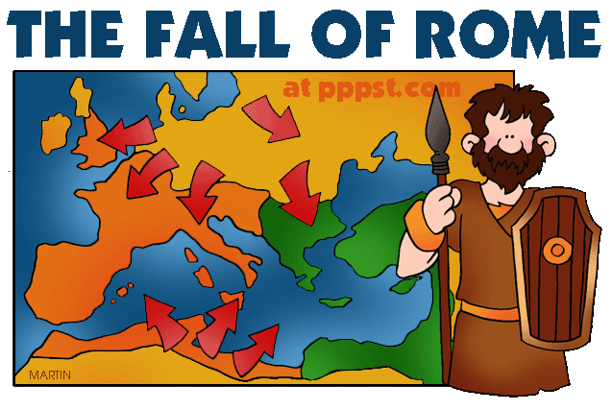
__________________________________
__________________________________
__________________________________
__________________________________
__________________________________
C. Causes:
1. Political
a. Government becomes _____________________.
b. People stop supporting government
c. ___________________
d. Divided empire becomes weak
e. _____________________________
2. Military
a. Germanic invasions (Attila the Hun)
b. ___________________________.
c. Little _____________ among __________________: hired soldiers.
3. Social
a. Decline __________________________: Disease & war
b. Decline in ______________ (patriotism, discipline & loyalty)
c. Devotion of upper class to __________________________.
4. Economic
a. ____________________ to support the army & bureaucracy
b. __________________ leave land: shortage of food
c. Reliance on ____________________
d. ______________________ disappears

D. _______________________________ of the Roman Empire, 476 A.D. is marked by Odoacer, ________________________________, _____________________________________________________.

Fall of Rome
Do Now: Read the following primary source and answer the questions.
“ The nation of the Huns…surpasses all other barbarians in wildness of life…and although the Huns do just bear the likeness of men (of a very ugly pattern), they are so little advanced in civilization they feed upon the raw flesh of any sort of animal. When attacked they fill the air with varied cries, they fight in no regular order or pattern, but by being extremely swift and sudden in their movements, they disperse, spread havoc over vast plains and pillage the camp of their enemy almost before he has become aware of their approach.”
~4th century poem

- What was the overall opinion of the Huns? _________________________________________
__________________________________________________________________________________________

- Why do you think this group was able to destroy the mighty Roman Empire? __________
______________________________________________________________________________________________________________________________________________________________________________

********************************************************************************************************
Summary: Based on our discussion, place a YES or NO next to the following which would be most appropriate in describing our society today and Roman society in its decline. BE PREPARED TO PROVIDE EXAMPLES.

USA 2000’s vs. Roman Empire 200-450 A.D.
Society (Yes or No) | U.S.A. | Roman Empire
1. Confidence in political leaders
2. Serious economic problems
3. Paid Professional army
4. A united sense of purpose
5. Strong central government
6.Taxes too high
7. Financial & military strength to control world events
8. Uneven distribution of wealth
9. Emphasis on honesty & hard work.
10. Law is above individual.
11. Significant Political Corruption

12. Make a prediction about the future of the United States. _____________________________
____________________________________________________________________________________________________________________________________________________________________________________
13. Was the Fall of Rome inevitable? What can the U.S. learn from their mistakes? ____________________________________________________________________________________________________________________________________________________________________________________14. What can you do to prolong the life of the U.S.? _______________________________________
__________________________________________________________________________________________

