Colonial Period – Independence Exam
100 point exam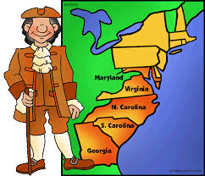
(30 MC, 2 Short Answer Questions)

Topics to be familiar with:
- Characteristics of Jamestown/Plymouth
- How democratic was colonial America? (Mayflower Compact, House of Burgesses, mercantilism, salutary neglect)
- Regional differences in the colonies (middle passage, triangular trade)
- Causes and Effects of French/Indian War (Albany Plan of Union, Proclamation of 1763)
- New Colonial Policy
- Colonist reactions to New Colonial Policy
- Declaration of Independence
- “Common Sense” / Committee of Correspondence / “No Taxation without Representation”

