Part A
Short-Answer Questions

Directions: Analyze the documents and answer the questions that follow each document in the space provided.

Document 1
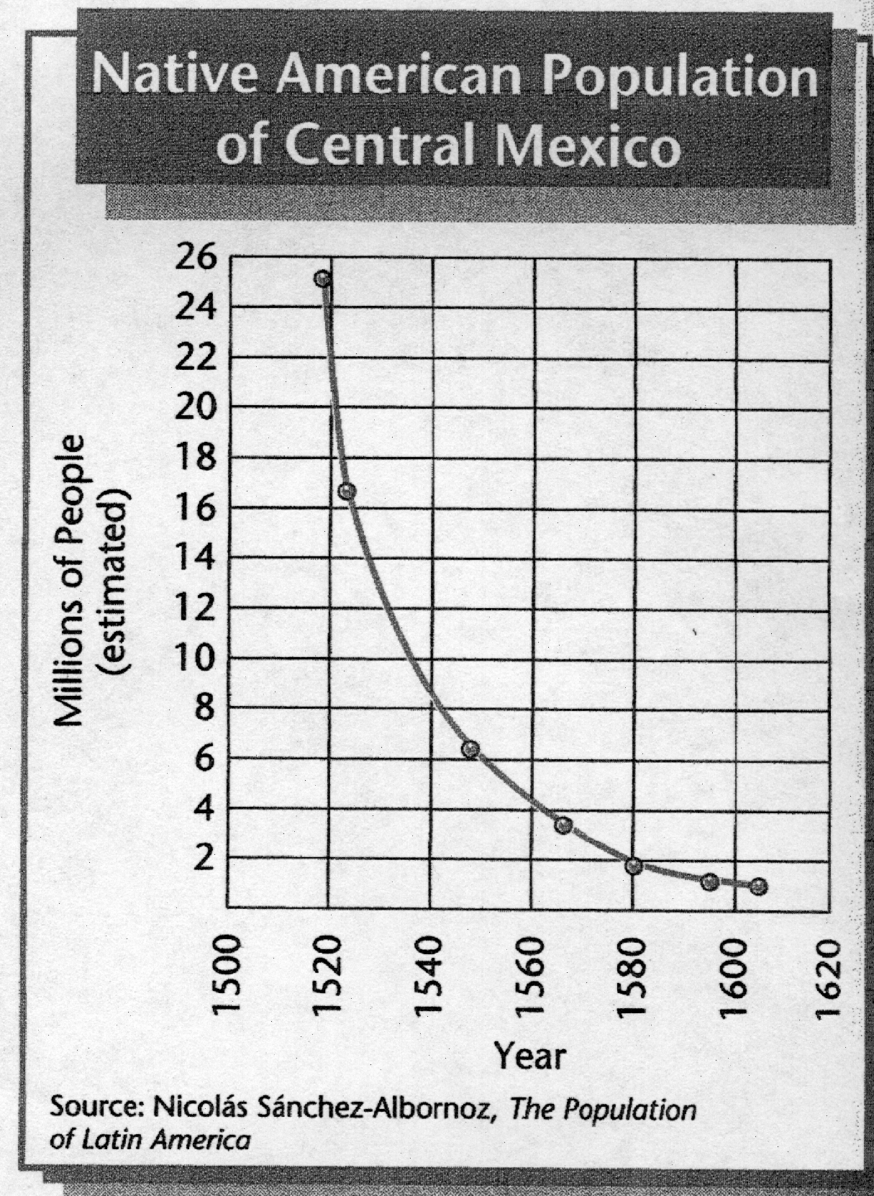

1. According to this graph, what happened to the Native American population of Central Mexico between 1500 and 1620?
________________________________________________________________

________________________________________________________________

Score

Document 2

“That there shall be a church, and parish priests or friars to administer sacraments, to perform divine worship, and for the conversion of the Indians.”
~From Columbus’ letter to King Ferdinand and Queen Isabella of Spain

2. According to Columbus’ letter, what was the purpose of establishing a church in the “New World”?

____________________________________________________________________________________________________________________________________________________

Score

Document 3
“… For the last forty years the Spanish have done nothing but slay, torment, and destroy the Indians with strange and new kinds of cruelty never before scene, or heard of …solely because they have made gold their final aim, seeking to load themselves with riches in the shortest time.”
~Bartolome de Las Casas

3. According to Bartolome de Las Casas, what motivated the Spanish to treat the Indians as they did?
____________________________________________________________________________________________________________________________________________________

Score

Document 4
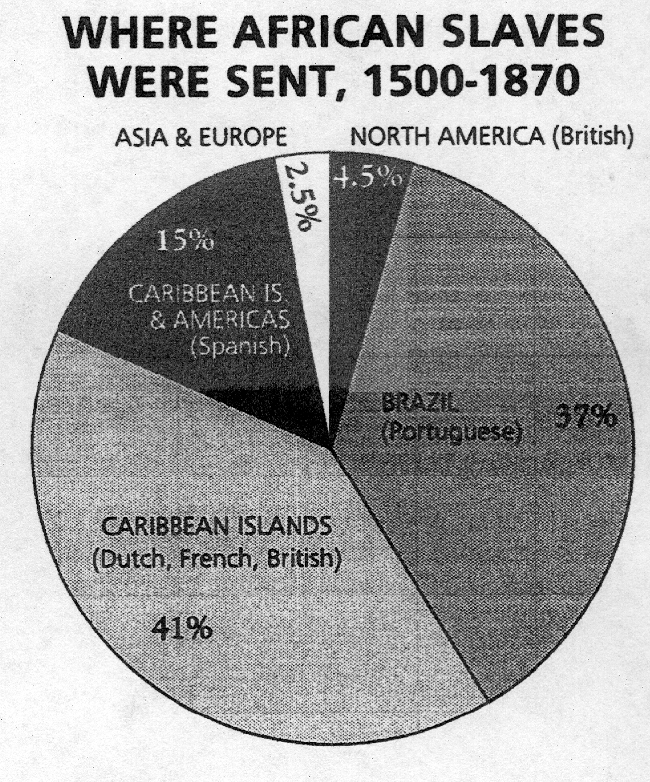
Slices of the Pie

Asia and Europe 2.5%

North America 4.5%
(British)

Caribbean Islands 15%
& Americas
(Spanish)

Brazil 37%
(Portuguese)

Caribbean Islands 41%
(Dutch, French, British)

4. According to the Graph, where was the destination of the majority of the African slaves brought to in the “New World” between 1500 to 1870?
____________________________________________________________________________________________________________________________________________________

Score

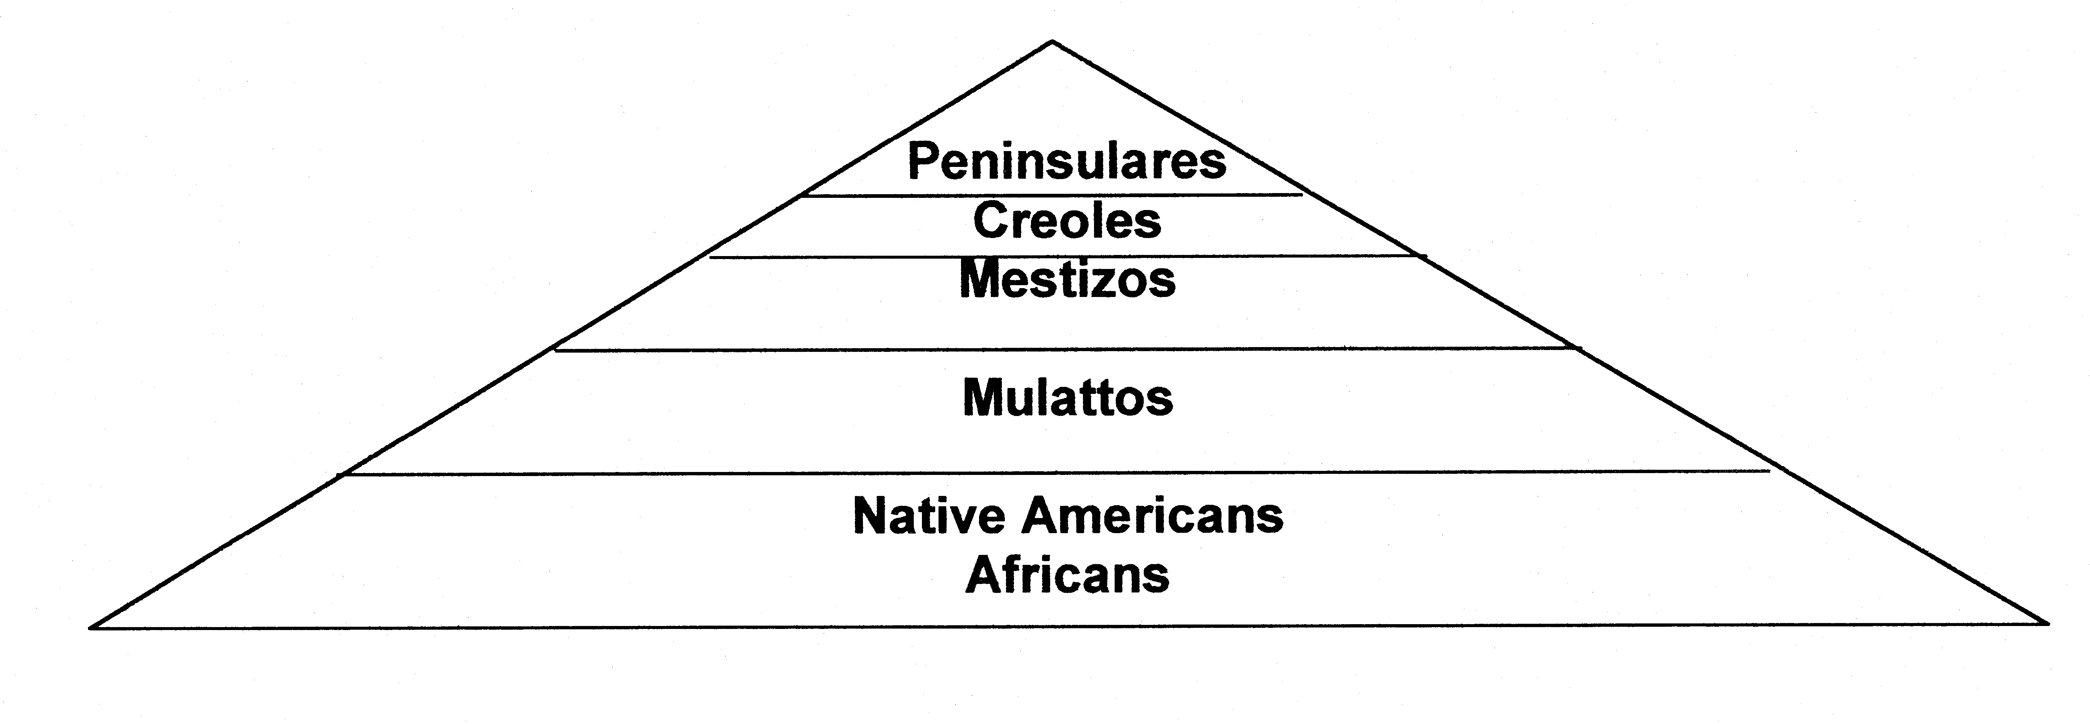
Document 5

5. According to the chart, what factors determined social classes in the Americas?
____________________________________________________________________________________________________________________________________________________

Score

- Discuss the effects of European exploration and colonial settlement on the social and religious institutions in Latin America.

