Name:
Indus Valley Mystery
Directions: Congratulations! You and your team have been assigned to investigate a new archeological discovery along the Indus River Valley at Harappa and Mohenjo-Daro. There are a great deal of artifacts and ruins that need to be analyzed. Use your knowledge of Social Studies to analyze and make inferences for each artifact. We will use your information to find more about the people of this area.

Artifact #1: bricks from both civilizations are uniform in size.

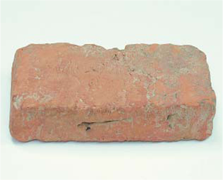

Artifact #2: cities set up in grid patterns with streets and a citadel dominating the area.
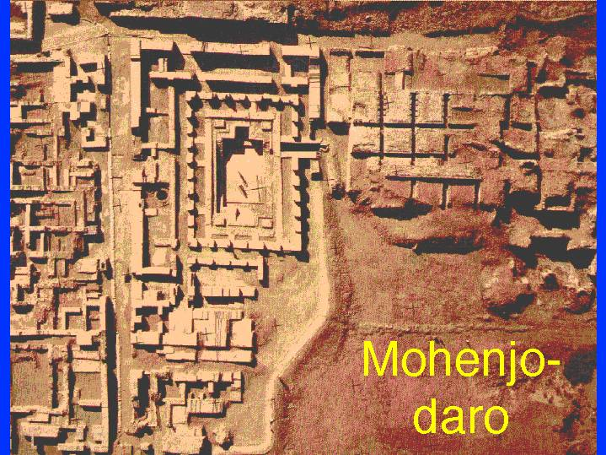

Artifact#3: sewer system, public baths, and drainage system
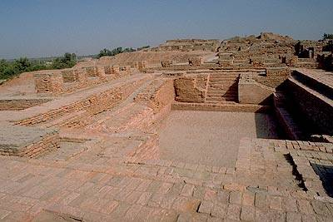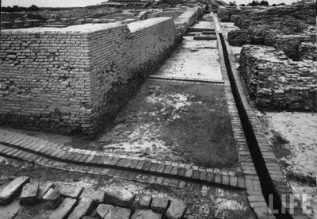

Artifact#4: hundreds of square seals on precious stone with writing (presently undecipherable) and pictures of animals.
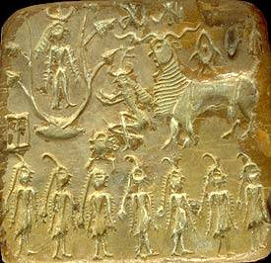

Artifact#5: large hollow buildings that contain ancient grains.
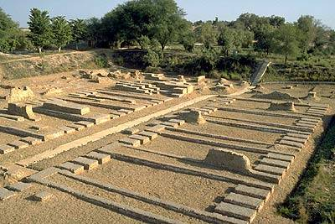
Artifact#6: large, brick city walls forty feet thick and fifty feet high.
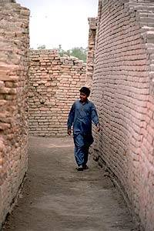
Artifact#7: artifacts of silver, tin and jade which are not native to Indus Valley.

