Name_____________________________ Gewitz--Global I
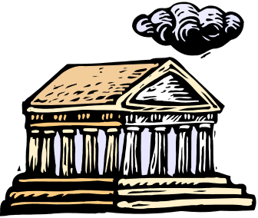

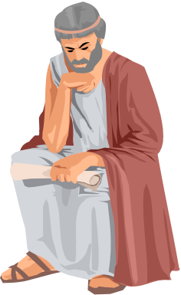

GREEK
CONTRIBUTIONS



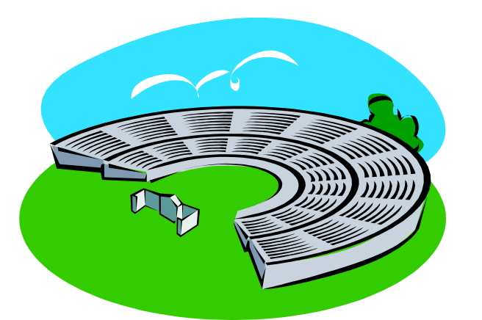

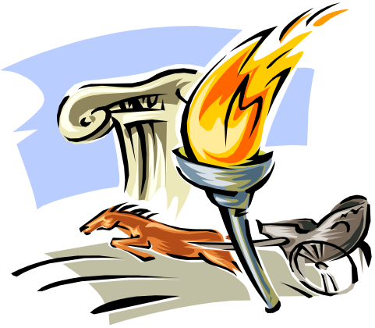

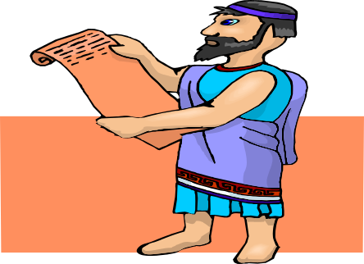

The Golden Age of Greece
Philosophers:

Architecture/Sculpture:

Science & Math:

Language:
Olympics:

Science, Mathematics and Medicine
It was the philosopher, Aristotle who engaged in many areas of scientific study: astronomy, biology, zoology (the study of animals), botany (the study of plants), and physics. Many other advances in medicine, math and science were made during the Hellenistic Age, following the conquest of Greece by Alexander the Great (Aristotle’s pupil).
The Hellenistic Age saw huge advances in astronomy, the study of the planets and the stars. The Greek astronomer, Aristarchus, concluded that the earth and other planets revolved around the sun (heliocentric theory). Unfortunately, his ideas were rejected at the time in favor of Ptolemy, who argued that the sun revolved around the earth (Geocentric theory). It would be 2000 years before Aristarchus’s theory was proved correct. Eratosthenes was able to estimate the circumference of the Earth within about 200 miles.
Many of these advances in astronomy were made possible by progress in the area of mathematics. Trigonometry was found during this period. Euclid, a mathematician, wrote a book called The Elements, which was used to teach geometry in some classrooms until 1903. For his work in this field, he became known as the “Father of Geometry”. Archimedes made further progress in geometry when he came close to calculating the true value of pi. He discovered laws of the lever and the pulley. He discovered the law of specific gravity after observing the displacement of his bath water one day in the public baths. Supposedly, he ran home naked screaming “Eureka!”, or “I have found it!” (His wife was very embarrassed.)
Many new medical advances were made in Hellenistic times. The famous medical school founded by Hippocrates, the “father of medicine”, continued to flourish. Hippocrates taught that health problems had natural causes. He operated on patients, reset dislocated joints, and put broken bones back in place. Graduating medical students today take the “Hippocratic Oath” in which they agree to rules of ethical standards by swearing to “help the sick...but never with a view to injury and wrong.”

Matching:
____1. Explained levers and pulleys | a. Hippocrates
____2. The “Father of Modern Medicine” | b. Eratosthenes
____3. Estimated the earth’s circumference | c. Aristarchus
____4. Said: earth revolved around the sun” | d. Aristotle
____5. Wrote a text on principles of geometry. | e. Archimedes
____6. Philosopher and scientist | f. Euclid

7. How did the theories of Aristarchus differ from those of Ptolemy?

8. Which of these discoveries do you believe made the biggest impact on our modern world or technology? Explain.

Architecture and Sculpture
Architecture is the art of planning and constructing buildings. Greek architecture reflects the Greek love of harmony, order, simplicity and beauty. No buildings were more important to the Greeks than their temples. When Pericles decided to rebuild Athens, he lavished attention on the Parthenon and other temples on the acropolis. Blessed with close marble quarries, the Athenians were able to build strong buildings.
The Parthenon, built to honor the Greek goddess Athena, took Phidias, the head sculptor, two years of planning before building began. The Parthenon, is supported by carefully carved and graceful columns that give the impression of lightness and height. There was a large room where a forty-foot statue of the goddess Athena stood. Originally the Parthenon was decorated with beautiful colors and decorations, which have all been stripped. The Parthenon was a symbol of the Greeks grace, simplicity and perfection, it stated, “Here is Athens, the glory of the world.”
There were originally two types of Greek columns, the Ionic and the Doric. The two types differed only in the details. The Doric is simpler and the Ionic is larger. The Parthenon is an example of Doric architecture. Later, during the Hellenistic Age, a third style Corinthian, was developed.
Many of our public buildings today are modeled after those of ancient Greece. The Lincoln Memorial resembles a Doric temple, the Jefferson Memorial has Ionic columns and the National Archives and Supreme Court buildings follow the Corinthian style.
Sculptor: The Greeks believed that the human body was a thing of beauty; their sculpture portrays the human form in a simple but graceful style. The chief subjects were usually gods and heroes (athletes, generals & statesmen) and they were most often portrayed as ideal or perfect figures. No potbellies or slouching shoulders on Greek statues!
Greek sculptors worked with many materials including wood, terra cotta, gold, ivory, bronze and of course, marble. Unfortunately, very few original sculptures remain. Much of what we think are Greek sculpture are actually Roman copies made centuries later. Phidias was the greatest sculpture and is responsible for the two statues of Athena in the Parthenon and the statue of Zeus at Olympus. Myron was another famous sculptor; unfortunately, we have none of his originals. His most famous statue, the Discobolus (Discus Thrower) shows an athlete at the moment when his body is tensed to throw the metal plate.

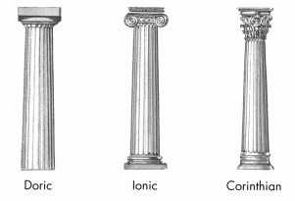

Architecture and Sculpture:

WORD SEARCH
D | H | A | I | H | S | A | E | C | A | R | G | I | S
R | T | C | Y | Y | T | E | M | P | L | E | Y | I | A
E | A | R | U | C | R | L | N | P | R | E | U | D | I
J | A | O | R | R | W | O | M | O | E | R | R | E | D
M | T | P | E | N | R | E | L | I | C | U | S | A | S
K | H | O | P | Y | T | P | I | G | C | O | R | L | A
L | E | L | M | A | R | B | L | E | U | I | E | S | I
M | N | I | F | Q | E | L | P | M | I | S | D | P | D
H | A | S | M | A | R | A | M | W | S | U | L | O | I
W | A | S | N | Z | E | S | S | A | S | C | K | I | H
Q | E | A | Y | N | O | M | R | A | H | D | F | H | P
W | R | Y | N | O | W | U | I | Y | B | X | H | O | P

Answer & Find:
- What quality is reflected in Greek architecture? _____________
- The Parthenon was built in honor of _____________.
- The Parthenon is located on the _______________ in Athens.
- The Parthenon was built of fine ___________.
- Statues of people were usually shown in their _________ form.
- The Parthenon can be described as ____________.
- The Parthenon showed the true ________ of Athens.
- The Parthenon was used as a ________.
9. ________ and ________ were two great Greek sculptors.

10. Why were figures portrayed as ideal figures?

11. What characteristics are common to Greek architecture, sculpture and painting?

12. Why do you think the U.S. would model our buildings after the Parthenon?

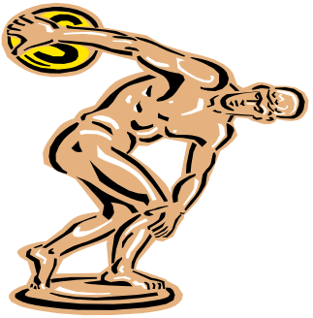

The Olympics
Then: From 776 BC to 393 AD (over 1,000 years) the Greek city-states ceased all warfare and thousands traveled to Olympia for five days in the late summer to attend the Olympic games. Athletes from all over the Greek world competed in a number of events and worshipped the gods at the temple of Olympia. The athletes competed not for money or material goods, but only for the honor of being the victor. The prize was a wreath made of olive leaves, considered sacred to Zeus. It is believed that the first winners of the games were descendants of the gods.
Before they were known as the Olympics, the games consisted of only one event, a 200-yard foot race. During this time, only men could participate or even watch the games. By 600 BC, new events became part of the Olympic festivities. These were foot races, chariot races and a five-sport pentathlon, which included wrestling, running, long jump, discuss throw and the javelin throw. Another new addition was the pankration, a savage sport that combined wrestling and boxing. Milo of Kroton was a famous Olympian for winning five consecutive wrestling titles. For kicks he would tie a cord around his forehead, hold his breath and break the cord with his bulging veins. (Don’t try this trick at home.)
Unlike today’s Olympics, for the first fifteen Olympics, the athletes competed naked. Supposedly, during the 720 BC games a runner’s shorts fell off. He still won the race and the other athletes felt that if they dropped their trousers they could win just like the other guy. The tradition continued to prevent competitors from concealing weapons in a warring society.

Now: The Modern Olympics Games started up again in 1896 in Athens, Greece. They have been held every four years since, except during World Wars I (1916) and II (1940 and 1944). The five rings symbolize the five geographic areas: Europe, Asia, Africa, Australia and the Americas. They are interlocked to represent sporting friendship.

True or False: If False put the correct answer in the space provided.
1. ____The Olympics started as a festival for the gods.____________________
2. ____ The Olympics has never been cancelled._________________________
3. ____ Swimming has always been a main event.________________________
4. ____ Olive oil was given to the losers.________________________________
5. ____ The five rings of the Olympics started in Ancient Greece._____________
6. Which events that started in Ancient Greece still exist in the modern Olympics, which do not?

7. Why do you think sports and fitness were important to the Greeks?

8. Explain how the ancient Olympics and Modern Olympics bring people together, even if they might be enemies?

Language
Have you ever heard the saying, “It’s Greek to me”? People use it when they can’t make sense out of something. But, most English speakers actually know quite a lot of Greek. Most of the alphabets of the Western civilizations are based on the ancient Greek alphabet. The Greek alphabet, originally taken from the Phoenician, began in 1400 BC and in 500 BC they began their writing from left to right. Before that time, most languages were written from right to left. This is still true of the Hebrew language.
Until about fifty years ago, many school children studied the ancient Greek language. Being literate in Greek was considered a sign of an educated person. College sororities and fraternities use Greek letters to name their organizations.
Approximately twelve percent of our words come from Greek roots. The Greek used words for many concepts and they ended up as part of the English language. Root words can be combined to form new words. The word alpha bet comes from alpha and beta, the first two letters of the Greek alphabet.

Put the correct English words described below in the blank spaces.
1. A place to put collections. Its name comes from the Greek word mouseion. _______________________  2. A professional person, from the Greek words archi (chief) plus tekton (builder)._____________________  3. Two Greek words are combined to name a type of urban area: meter (mother) plus polis (city). Together the words mean “Major city”. ____________________  4. The study of the earth’s surface based on these Greek words: ge (earth) plus graphein (describe). _______________________  5. We use letters to create words. The name for this system of letter, from the Greek word alphabetos. _________________________ | 6. A large African mammal, from the Greek word hippos (horse) plus potamos (river). The animal lives chiefly in the water. ___________________________  7. Another name for Earth and other heavenly bodies in the universe comes from the Greek word planetos (wanderer). ____________________  8. A vehicle used by many people today. Its name comes from the Greek words bi (two) plus kuklos (wheel). ______________________  9. An infection of the lungs that causes breathing difficulty, from the Greek word pneuma (breath). ____________________  10. The bone structure of the body, from the Greek word skeletos (dried up). ______________________
On separate paper, write as many English words as you can by combining the Greek root words.
anti-against  auto-self  anthro-human  astro-star  bio-life | cracy-government  dem-people  hydro-water  meter-measure  logy-study, science | geo-earth  macro-large  micro-shell  phob-fear  scop-see, look at | graph-draw, write  mega-big  mono-single, alone  phon-sound  poly-many
1. Where did the Greeks get their alphabet?

2. Why do you think it changed over time?

Greek Gods and Goddesses

The Greeks believed that in the beginning of the earth there was a huge void called Chaos. From this void, eventually, came the Titans led by Chronos. Zeus, the son of Chronos, was the leader of the next race of gods, the Olympians. These were the gods and goddesses worshipped by the ancient Greeks. The Greeks would use oracles, priests or priestesses, who spoke to the gods. The Olympian gods were human in form. However, they were greater, more powerful and more beautiful than mortal man. The Greeks prayed to these Olympians and made offerings of drink and food, for divine help and favors.

There were endless religious festivals in every part of Greece. There were also shrines and statues to the gods in every part of Greece. The magnificent Parthenon of Athens honored the goddess Athena. But the Greeks religion lacked scriptures. Since they had no strict theology, they were able to question literally everything in pursuit of the truth.

Use the information listed to identify the Greek gods and goddesses on the other side. Indicate your answers with the letters next to the picture.

Greek Gods & Goddesses Letter
1. Zeus: supreme ruler. He was the cloud gatherer, lord of the sky and the rain god. He also wielded the terrible thunderbolt.
2. Hera: Zeus’s wife and sister. Protector of marriage and the home.
3. Poseidon: Zeus’s brother. God of the sea. Gave the horse to man.
4. Hades: Brother of Zeus and Poseidon. Ruler of the underworld and the dead. The Greeks had a negative concept of the afterlife. Therefore, Hades was not widely worshipped.
5. Pallas Athena: Daughter of Zeus alone, she had no mother. In the Iliad she is a battle goddess. Later she is seen as the goddess of reason, wisdom and purity.
6. Apollo: Son of Zeus and Leto. He was the healer, the archer god, sun god, god of light and master musician.
7. Artemis: Apollo’s twin sister. She was the lady of wild things, the huntress, maiden and moon goddess.
8. Aphrodite: Goddess of love and beauty. She was “foam-born.” In most tales she is the wife of Hephaestus, god of the forge.
9. Hermes: Son of Zeus. Messenger to the mortals, god of commerce, god of thieves and mischief-makers.
10. Ares: Son of Zeus and Hera. God of war. He was bloodstained and murderous.
11. Hephaestus: was the god of fire and artisans. He was ugly and lame and was the protector of smiths.
12. Hestia: Sister of Zeus. Goddess of the hearth, the symbol of home.

Greek Gods & Goddesses


