Name___________________________ Date____________
US History and Government Period_______

Activity: Creating Campaign Buttons for the Political Parties from 1850-1860.

Directions: Using the internet library website, navigate and check out the encyclopedia sites to find the information about the major political parties from 1850-1860.

Part I: Use the chart below to organize information about the following parties:

Party | Major Beliefs | Follower
Free-Soil
Know-Nothing
Republican
Democratic

Part II: Designing the Campaign Button
Guidelines: Your campaign button should:
- Be simple, but indicate something about the position of the party on certain issues
- Include both words and pictures (use phrases that you think will “sell” the party and make people want to join).
- Be creative and HAVE FUN!

Creating a Campaign Button

Teacher Name: Mrs. Gewitz
Student Name: ________________________________________

CATEGORY | 4 | 3 | 2 | 1
Content - Accuracy | All facts in the button are accurate. | 99-90% of the facts in the button are accurate. | 89-80% of the facts in the button are accurate. | Fewer than 80% of the facts in the button are accurate.
Attractiveness & Organization | The button has exceptionally attractive formatting and well-organized information. | The button has attractive formatting and well-organized information. | The button has well-organized information. | The button's formatting and organization of material are confusing to the reader.
Graphics/Pictures | Graphics go well with the text and there is a good mix of text and graphics. | Graphics go well with the text, but there are so many that they distract from the text. | Graphics go well with the text, but there are too few and the button seems "text-heavy". | Graphics do not go with the accompanying text or appear to be randomly chosen.
Spelling & Proofreading | No spelling errors remain after one person other than the typist reads and corrects the button. | No more than 1 spelling error remains after one person other than the typist reads and corrects the button. | No more than 3 spelling errors remain after one person other than the typist reads and corrects the button. | Several spelling errors
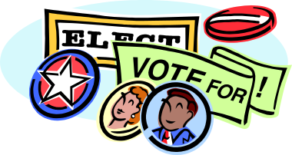
Total Points:

SAMPLE BUTTONS FOR A SIMILAR PROJECT



