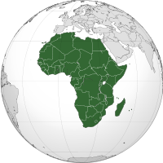
African Nationalist Movements
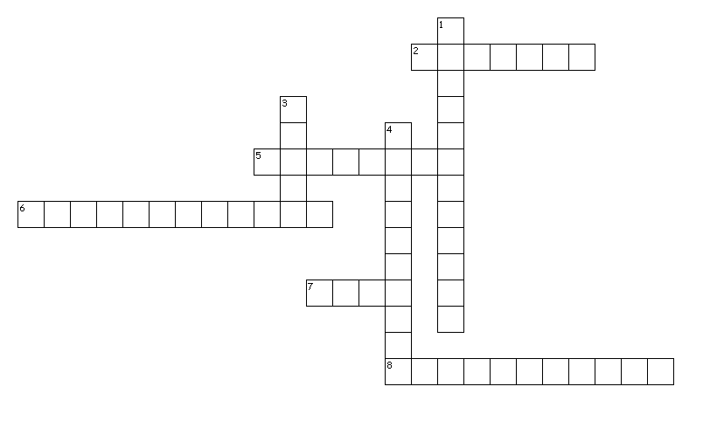
Across
2. Organized nonviolent strike
5. Obstacle to unity
6. Worked to liberate Gold Coast
7. This war caused dissatisfaction with Europe
8. Loyalty to your common culture and history
Down
1. Kenyan Nationalist leader
3. First African colony to gain independence from Britain
4. Movement to create United States of Africa

